Maintenance Manager
Release Notes v4.0.5.2

Contents
1 Document Control 3
1.1 Author 3
1.2 Document Summary 3
1.3 Document History 3
1.4 Reference documents 3
1.5 Distribution 3
1.6 Quality Assurance 3
2 Introduction 4
3 New Functionality 4
3.1 Product Options 4
3.2 Enhancements 4
3.3 Maintenance Manager / TMA Interface 5
4 Log No. Summary 39

- Document Control
  - Author
Exor Development

  - Document Summary
This document provides a list of all Logs fixed in this release and information about new functionality.

  - Document History

Document History
Revision | Date | By | Description
1.0 | 20-Feb-2009 | Exor Development | First Edition

  - Reference documents
None

  - Distribution
Exor Customers, Partners and Staff

  - Quality Assurance
Document Details
File | Prepared By
Maintenance Manager Release Notes v4.0.5.2 | Exor Development
Document Name | Reviewed By
Maintenance Manager Release Notes v4.0.5.2 | Mark Lowe
Version | Approved for issue by
1.0 | Colin Stewart
Date of Issue | Support Manager
20-Feb-2009 | Graham Anns

- Introduction
This document defines the changes made to Maintenance Manager following the release of Maintenance Manager v4.0.5.2. It is specifically targeted at users and system administrators of the exor systems.

It is not intended to be a full system description but a guide to indicate what changes have been made, why they have been made and the potential failings if this upgrade is not applied.

After reading through this document, should you have any need for training or consultancy then please contact your exor account manager.

- New Functionality

3.1 Product Options

The following product options are new and should be set appropriately:

WCCOMPLETE – When set to “Y” allows WC file to complete a defect or repair

XTRIFLDS – Switches version of interface files – should be set to 2-1-3

3.2 Enhancements

Support Reference | Module | Issue
717676 | MAI3800 | When an order is actioned either manually or via a WC file the associated defect should be completed.
715843 | MAI3800 | X and Y co-ordinates now displayed on defects and Inspections form

3.3 Maintenance Manager / TMA Interface

General Information
Maintenance Manager Works Ordering is used to manage Defect clearance, Small Scheme and Cyclic Maintenance work orders. With the introduction of the TMA the Local Authority is required to register and manage the lifecycle of a Notice through different phases of work in order to maintain parity with existing Undertakers. In essence this means that the User must be able to raise and associate different notice types with a work order line.
The user group requirements were that any changes made were to have as minimal effect on the existing work ordering modules MAI3800 & MAI3800a as possible.

The changes to Maintenance manager to cater for the link with the TMA are as follows:

- Minimal Changes to Work Ordering - MAI3800 and Mai3800a modules
- New Module Work Order TMA Interface – TMA3990
- Minimal Changes to Send Notice to Register – TMA1800

Maintain Work Orders – MAI3800 and MAI3800a
Work Orders window
A number of new fields and buttons have been added in order to support the changes being made for the MAI / TMA interface. These changes are detailed below; the screenshot has been annotated to highlight the areas of change.

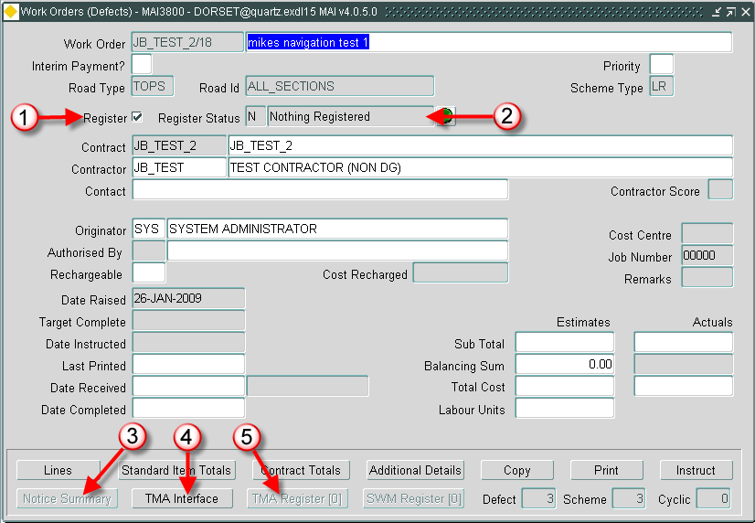

Register (Optional) (Checkbox)
When ticked and saved any existing work order lines will be ticked, any work order lines subsequently added to the work order will have to be ticked manually. If unticked it will de-select all work order lines that have not had a notice generated.
Register Status (Display Only)
The calculation of the Register Status has been amended to be based upon the following logic:
- N-Nothing Registered - One or more WOLs have been ticked as registerable but no Notices have
been sent for any of them.
- O-Outstanding - One or more WOLs have been ticked as registerable and at least one Notice has been
sent for at least one of them.
- C-Complete - All WOLs that have been ticked as registerable have had a “0600” Notice sent.

[Notice Summary] Button
The new Notice Summary button is enabled if the TMA Product is licensed and one or more Notices have been sent for the Work Order. Calls the Work Order TMA Interface - TMA3990 and Navigates to the ‘Work Order Lines’ tab.

[TMA Interface] Button
The TMA Interface button is enabled if the TMA Product is licensed and one or more Work Order Lines are ticked as Registerable. Calls Work Order TMA Interface - TMA3990 and navigates to the ‘TMA Noticing’ tab.

[TMA Register] Button
The TMA Register button is enabled if the TMA Product is licensed and one or more Notices have been sent for the Work Order. Calls Works - TMA1000 and displays the TMA Works that have been created for the Work Order.

Work Order Lines window

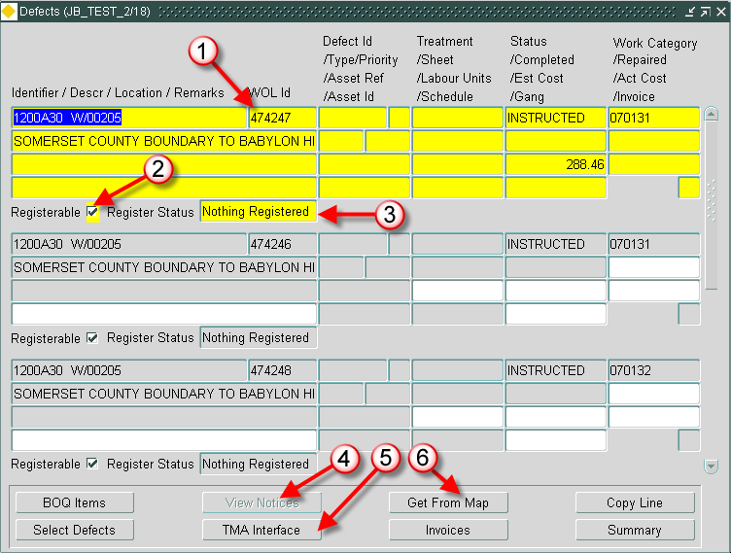

Work Order Lines (Display Only)
This will display the Work Order Lines internal Id number.
Registerable (Checkbox)
This tick box is used to indicate whether an individual line should be registered with TMA. If this is ticked and the Work Order level Register tick box hasn’t then it will automatically be updated.

Register Status (Display Only)
This new Line level Register Status field indicates the Noticing Status of the individual Work Order Line. The status of this field depends on the following logic:
- Nothing Registered - The WOL has been ticked as ‘Registerable’ but no Notices have been sent for it.
- Outstanding - The WOL has been ticked as ‘Registerable’ and at least one Notice has been sent for it but not a 0600 – Works Stop Notice.
- Completed - The WOL has been ticked as ‘Registerable’ and a 0600 – Works Stop Notice has been sent.

[View Notices] Button
This new button is enabled when one or more Notices have been sent for the currently selected Work Order Line. Calls Work Order TMA Interface - TMA3990 in read only mode and navigates to the ‘Work Order Lines’ tab.

[TMA Interface] Button
This new button is enabled when one or more Work Order Lines are ticked as ‘Registerable’. Calls Work Order TMA Interface - TMA3990 and navigates to the ‘TMA Noticing’ tab (this is the same functionality as the Work Order level [TMA Interface] button).

[Get From Map] Button
This new button is enabled when the WOL Id is populated and the Work Order Line status is not COMPLETE. Calls Locator - NM0572 and allows the user to digitise a new location or shape for the defect or work order. This will give the user the option to enter a point, Polyline or Polygon that better represents the location and the shape of the work to be carried out on the selected work order line. There is more detail later in this document.

Work Order TMA Interface – TMA3990

General Information
This is a new module that allows the user to manage the notices that are to be generated for the work order lines in both Work Orders (Defect and Small Scheme) - MAI3800 and Work Orders (Cyclic) - MAI3800a.

The purpose of this module is:

- To automatically derive and associate one or more USRN’s for each instructed, registered work order line. Multiple work order lines may be on one notice if those lines all fall on the same street. Multiple Notices may be generated for one work order line if that work order line spans a number of streets.
- To facilitate the production of key TMA notice against each affected USRN throughout the life cycle of the works

This module can be called in a number of ways:

- Using fastpath and the module Id – TMA3990
- By the selection of the [TMA Interface] button form within the Work Ordering Modules MAI3800 and MAI3800a
- Directly from the Menu as shown below, the user will have to query back the work order number required.

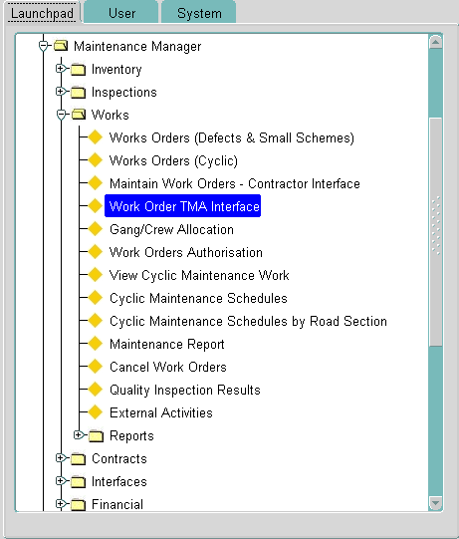

TMA Noticing Tab
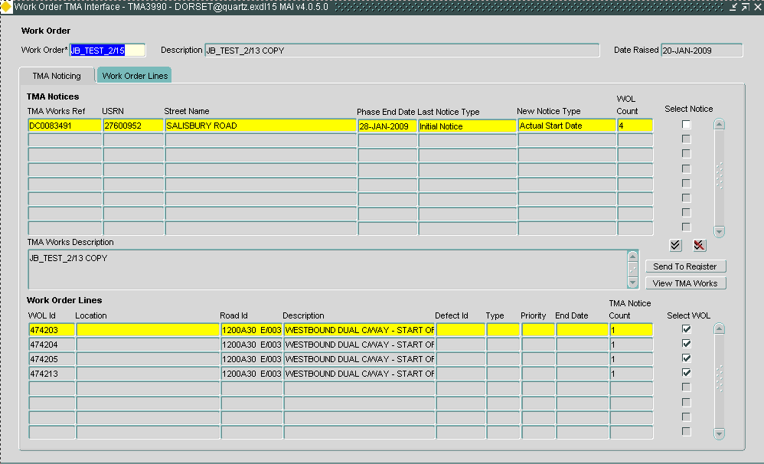

These three fields will be automatically queried if TMA3990 is called from the Work Ordering modules. If called from the Menu the user will have to query back the required work order number.

- Work Order
- Description
- Date Raised

TMA Works Ref (Display Only)
When the notice has been sent to the TMA Register the Works reference will be displayed. This will be blank until the first notice is sent to the register.

USRN (Display Only)
The USRN that has been derived against the work order line will be displayed.
- For Defect Clearance work order the USRN’s will be derived based on the Road Section against the defect
and the xy, measure available on the defect to find the accurate USRN.
- For Small Scheme and Cyclic Work orders USRN’s will be derived based on the Road Section against the
Work Order Line.

There are cases when USRN cannot be determined for the Road Section. In such cases the Street field will be populated with Street cannot be determined for the Road Section and the Select Notice check box will be disabled. User will not be allowed to send any TMA Notice against the work Order Line.

Street Name (Display, Query)
The Street Name for the derived USRN will be displayed.

Phase End Date (Display, Query)
This is the TMA actual end date, if this is not available the estimated end date will be displayed.

Last Notice Type (Display, Query)
The last notice type that has been sent from the list of notices displayed below will be displayed. For the available notices, see below:

Next Notice Type (Display, Query)
The next notice from the available list of notices for the selected regime will be displayed. For the available notices, see below

How the Notice Types are derived.
As requested by the user group only a subset of works notices will be processed from this interface. Other notice types will have to be manually entered using the TMA modules.
The noticing regime (Notice or Permit) will be derived from the street characteristics.
The following notice types may be used:

- 0200-Initial Notice
- 0210-PAA (Major) / Permit Application (Non-Major)
- 0300-Confirmation Notice
- 0310-Permit Application
- 0400-Actual Start Date
- 0600-Works Stop

Once the noticing regime has been derived and a notice has been sent only notices relevant to the specific regime will be used.

WOL Count (Display Only)
The number of work order lines associated with Notice will be displayed. A summary of the work order lines for this notice will be displayed in the work order lines area at the bottom of the window.

Select Notice (Checkbox)
Select / Deselect the notice that is to be progressed.
The user now has two options for a selected notice

- Select the [Send to Register] button to send the notice to Send Notice to Register – TMA1800. The system will send the ‘Next Notice Type’ notice. The user can then make changes and view errors and warnings prior to sending to the Register.

- If a notice has already been sent they can select the [View TMA Works] button to view Works – TMA1000.

Select all and deselect all can be used to select the notices if required.

When the Checkbox is selected the following validation is carried out:

- If a notice is selected the system will search for all TMA Notices against the work order line and marks all notices associated with the work order line as selected
- If a notice is selected that has multiple work order lines then all the notices against those work order lines will be selected

TMA Works Description (Display Only)
The Works Description that had been entered and edited using Send Notice to Register - TMA1800 will be displayed.

WOL Id (Display Only)
The unique system generated work order line Id will be displayed.

Location (Display Only)
The defect location will be displayed if the selected work order line is a defect clearance line.

Road Id (Display Only)
The road id for the selected work order line will be displayed.

Description (Display Only)
The road section description for the work order line will be displayed.

Defect Id (Display Only)
For defect clearance work order lines the defect Id will be displayed.

Type (Display Only)
For defect clearance work orders the defect type code will be displayed, for example POTH.

Priority (Display Only)
For a defect clearance work order the defect priority will be displayed, for example 2.1.

End Date (Display Only)
For defect clearance work orders the Defect Due by date will be displayed. For small scheme and cyclic work orders the Target Date will be displayed.

TMA Notice Count (Display Only)
The number of notices that this work order line is on will be displayed. Small scheme and Cyclic work order lines may span more that one USRN.

Select WOL (Checkbox)
This Checkbox is used to include or exclude a work order line from the highlighted notice above. Default for the highlighted notice is to select the Checkbox.

When the Checkbox is unchecked the following validation is carried out:

- If it is the only WOL against the selected Notice and the WOL has only one Notice against it, if the check box
gets deselected, the Select Notice check box becomes non selectable for this WOL so no notice can be
generated.
- If it is not the only WOL against the selected Notice and the WOL has only one Notice against it then the check box gets deselected. The Select Notice checkbox remains checked for those work order lines that remain against the notice so the notices can be generated.
- If it is the only WOL against the Notice and the WOL has more than one Notices against it then, a warning is issued, WOL has more than 1 USRN’s, deselecting this WOL will not create any notice against it. The check box get deselected and also deselects this WOL from other TMA Notices in the form and the Select Notice check box becomes non selectable for this WOL so no notice can be generated.

Show Map, when the user has highlights a notice in the top half of the form they may select the [Show Map] button to display the USRN that has been selected.

Work Order Lines Tab
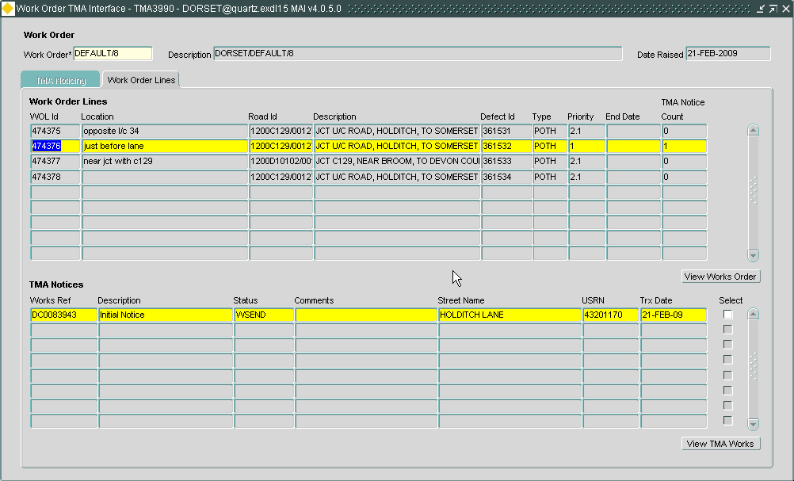

This tab shows the information in the reverse way to that of the TMA Noticing Tab.
If this module is called directly from the menu this will be the default tab the user will be presented with.

All of the fields within this tab are Display only with the exception of:

Select (Checkbox)
This checkbox is selected followed by [View TMA Works] to take the user to Works - TMA1000 to display the works details for the selected notice.

[View Works Order] Button
If this module has been called from the menu this will display Works Orders – MAI3800/MAI3800a.

Send Notice to Register – TMA1800
General Information
When the form is called from TMA3990 it will automatically query back the details of the “candidate” notices that the user asked to be produced.
If no notices were selected in TMA3990, then the message ‘No records to process’ will appear when the form starts. Once the alert box has been dismissed the form will exit and you will return to where you came from.

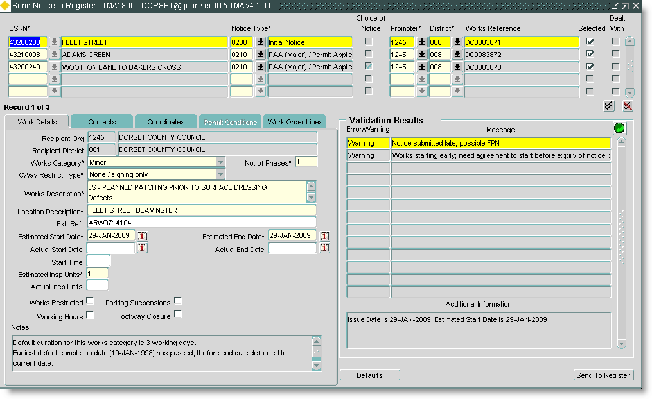

Upper Section
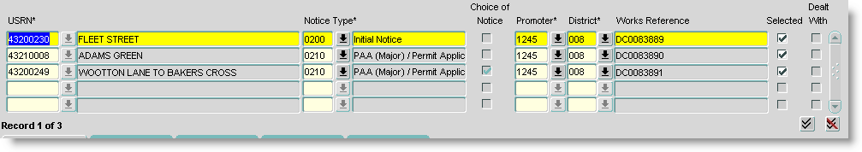
This section of the form will display all the notices that were selected in Work Order TMA Interface – TMA3990

USRN (Display Only)
This will display the USRN and Street Name as selected in TMA3990, when called from TMA3990 the street cannot be updated.
When Called from Enquiries – DOC0150 the street can be changed.

Notice Type (Default, Update) List
The notice type will default to the value displayed in TMA3990. The list of values will present the relevant notice types (Notice or Permit) from the following:

- 0200-Initial Notice
- 0210-PAA (Major) / Permit Application (Non-Major)
- 0300-Confirmation Notice
- 0310-Permit Application
- 0400-Actual Start Date
- 0600-Works Stop

Choice of Notice (Checkbox) List
This will be ticked if there is more than one notice type that can be sent. For example:
- The street is on a permit and a NRSWA regime and an 0200/0210 needs to be picked
- There is a choice between sending an 0300 or jumping straight to a 0400.

Promoter Org / District (Default, Update) List
This will default to the current users org/district as defined in My Districts – NSG0130 . This can be updated if required

Works Reference (Default)
This will display the Work Order Number as selected in TMA3990.

Selected (Checkbox)
This will automatically be ticked unless another user is updating the record in the TMA. This will be selected followed by the [Send to Register] button to send the notices to the register.
This cannot be selected once the ‘Dealt With’ checkbox has been selected.

Dealt With (Checkbox)
This will automatically be unticked unless another user is updating the record in the TMA. This will be checked automatically once the notice has been successfully sent to the register.

Work details tab

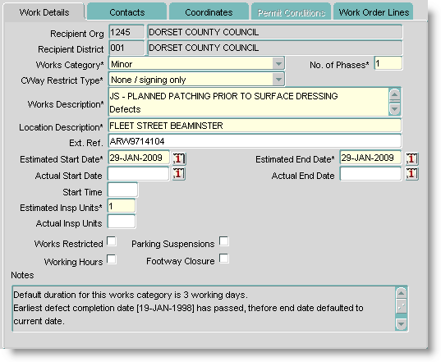

Recipient Org/Dist (Display Only)
This will display the primary recipient of the given notice type based on the USRN that the notice is for.
Note:
For 0200 and 0210 notices the primary recipient of the notice is derived from the street ASD. If there are a number of interested parties in the street, copy recipients are identified and included on the notice but not shown on the form.
For other notice types the primary and copy recipients of the opening 0200/0210 notice are identified and those are the ones included on the notice. As before, copy recipients may be included on the notice but not shown on the form

Works Category (Default) List
For Initial notices this will display the default works category, as set up in the [defaults] button. This can be amended if required. if changed it will update the estimated start date field.
For other notices it is the current value from the works/phase.

Number of Phases (Default)
For Initial notices this will display the default value as set up in the [defaults] button. This can be amended if required.
For other notices it is the current value from the works/phase.

Works Description (Default)
For Initial notices this will display the maintenance manager work order description then a list of all the defects associated with the relevant work order lines. This can be updated if required.
For other notices it is the current value from the works/phase.

Location Description (Default)
For Initial notices this will display the location of the first work order line with a location. This can be amended if required.
For other notices it is the current value from the works/phase.

Estimated Start Date (Default)
The estimated start date will be displayed. This can be updated.
The system will derive the estimated start date based on the following:
- Get the earliest repair due date from the associated work order lines (defect clearance).
If this does not exist it will use the work order target completion date.
- Work out what the default duration is for the category of works being noticed from metadata.
An example is shown below:

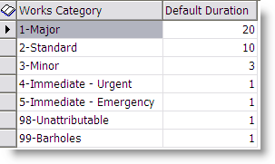

- Work out the TMA notice period for the category of works/notice type being produced

For example.
If we have a value for the target date

If target date is today OR in the future then
end date = target date
start date = estimated end date minus the default duration. Ensure that start date cannot be < today.
Else if that target date < today then
estimated end date to today
estimated start date to today
Else
start date = today
end date = start date plus the default duration.
End if

Estimated End Date (Default)
This will default to the earliest start date for the individual work order lines or the target date for the work order. This can be updated.

Actual Start Date (Default)
For Initial notices this will be null. This can be updated.
For other notices it’s the current value from the works/phase.
If that value is null and you’ve instructed TMA3990 to send an Actual Start Notice then the value will get defaulted to the estimated start date.

Actual End Date (Default)
For Initial notices this will be null. This can be updated.
For other notices it’s the current value from the works/phase.
If that value is null and you’ve instructed TMA3990 to send an Actual Start Notice then the value will get defaulted to the estimated end date.

Estimated Insp. Units (Default)
For Initial notices this will display the default value, as set up in the [defaults] button. This can be amended if required.
For other notices it is the current value from the works/phase.

Actual Insp. Units (Default)
For Initial notices this will default to null. This can be updated.
For other notices it is the current value from the works/phase.

Works Restricted
Working Hours
Parking Suspensions
Footway Closure (Checkbox, Default)
For Initial notices this will display the default value, as set up in the [defaults] button. This can be amended if required.
For other notices it is the current value from the works/phase.

Notes (Default)
Populated with relevant details as to how the estimated start/end dates are derived when the form is invoked with the intention of sending an initial notice.
Can also contain a message about locking – should there be a locking issue.
Note:
The notes do not change as you change attribution of block items i.e. they are static and a way of informing the end user how the original values on the record were derived.

Contracts tab
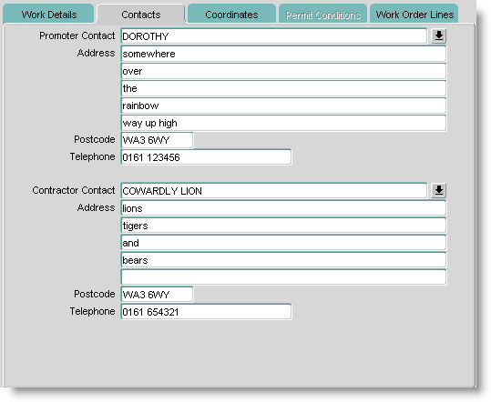

Promoter Contact (Default)
For Initial notices this will display the default value, as set up in the [defaults] button. This can be amended if required.
For other notices it is the current value from the works/phase.

Contractor Contact (Default)
For Initial notices this will display the default value, as set up in the [defaults] button. This can be amended if required.
For other notices it is the current value from the works/phase.

Co-ordinates tab
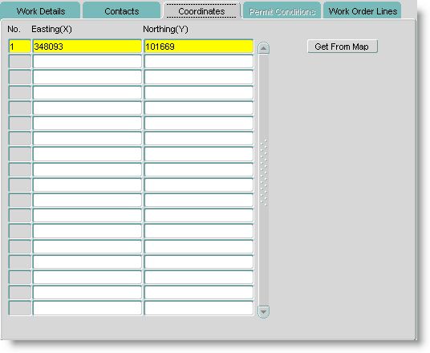

Easting(X) and Northing(Y) (Default)
For Initial notices this default to the x/y value at the start of the street.
To update the co-ordinates do the following:
- Select the [Get from Map] button, this will take you to Locator
- Select send multiple point to application, digitise a new line, double click the mouse to end selection
- This will return you to the form and display the new co-ordinates.

Permit Conditions tab
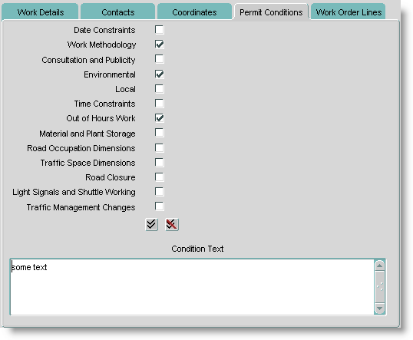
On entering this tab, all checkboxes will be unticked and the condition text will be null.
Work Order Lines tab
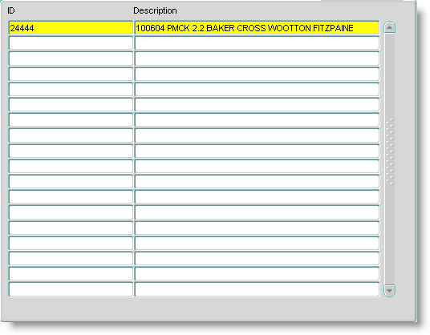

Id (Display Only)
This will display the unique system generated work order line Id.

Description (Display Only)
This will display a concatenation of Defect Id, Defect Type, Priority and Location.

Error Stack

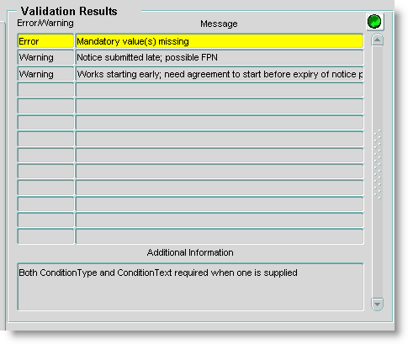
This works in the same way as the error stack in TMA1001. This will display the errors and warnings for the selected notice. The highlights error will have a more descriptive text in the Additional Information window.
The errors and warnings are refreshed as the user moves from notice to notice or by the selection of the green refresh button.

Defaults button
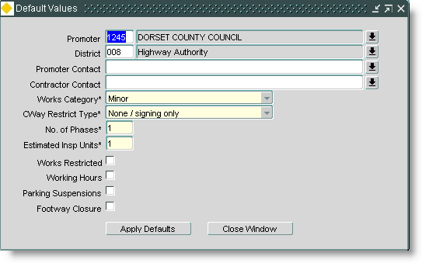

The [Defaults] button will display the defaults window. These defaults are set for the selected set of notices in the current session. To permanently change the defaults for the system you will need to speak with Support because the following table will need updating – TMA_SEND_TO_REGISTER_GATEWAYS.

The [Apply Defaults] button will cycle through all the notice records selected and update the relevant attributes with the default values set.
Send to Register button
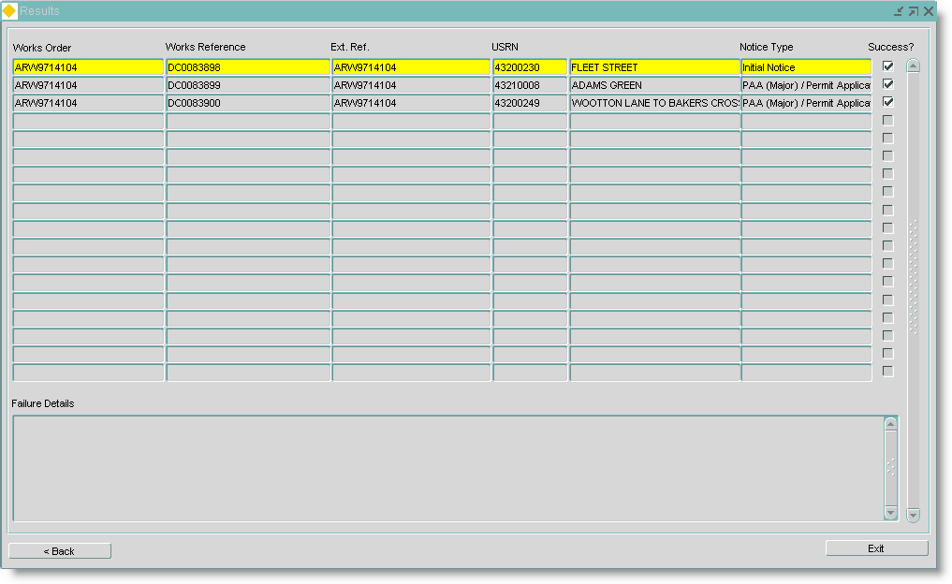

Window is displayed when the ‘Send to Register’ button is selected.
Each selected notice will have a record displayed in the results window showing whether or not the attempt at registration was successful.
When successfully registered the ‘Dealt With’ checkbox for the notice record is ticked so it cannot be re-noticed.
The [< Back] button takes you back to the main screen.
The [Exit] button will close the form and return you to TMA3990.

Configuration

User Roles
Each user that needs to use the Work Order TMA Interface will need a role assigned to give them access to MAI3800, TMA1800 and TMA3990

You get the following module roles created “out of the box” when TMA is implemented.

TMA1800
- TMA_USER

TMA3990
- TMA_USER

It is envisaged that each of these users will therefore need the role of TMA_USER assigning.

User Org/District
For a default promoter org/district to be assigned to a works in TMA1800, each user that needs to use the Work Order TMA Interface will need to have a default org/district created using NSG0120.
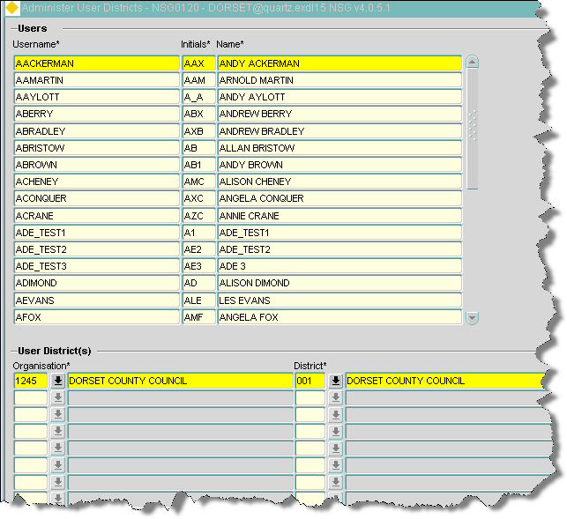

Standard Text
The works description and location fields in TMA1800 are receptive to standard text, should it be configured.

Work Orders – MAI3800 – View through Locator
General Information
When a work order has been created and saved, the complete work order can be viewed through locator by selecting the Show Map button when in the work order screen as shown below:

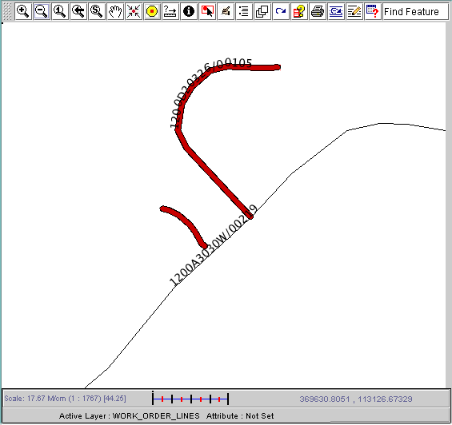

If the button is pressed from the Work Order Lines canvas then only then shape for the current Work Order Line will be highlighted in the Map.
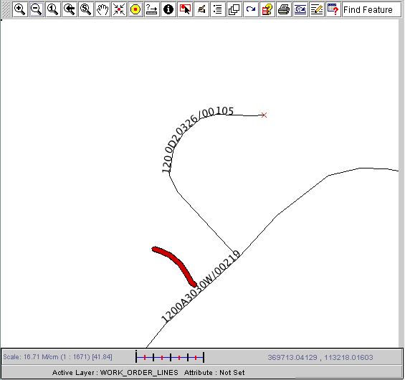

Work Orders – MAI3800 – Edit Default WOL Shape
General Information
When a work order line has been created against a work order it has been requested that the user be able to digitise a new location or shape that more accurately represents the work order line.
In order to edit the default shape of a Work Order Line the [Get From Map] button on the Work Order Line window should be used:

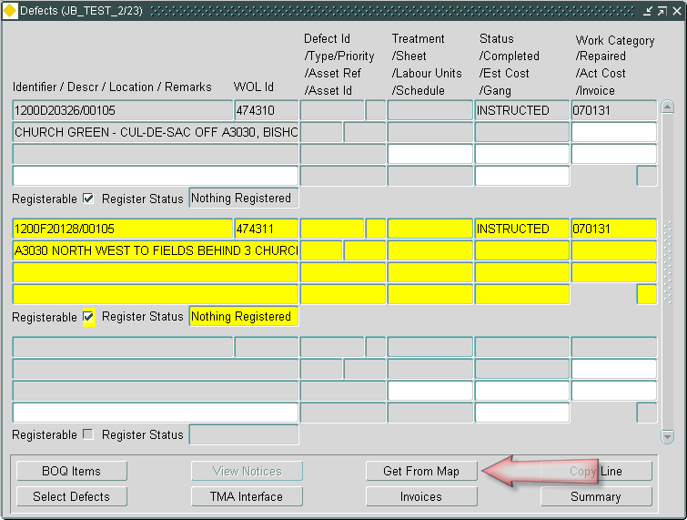

The [Get from Map] button is only enabled when the Work Order Line is populated and is not COMPLETED.

Once the [Get From Map] button has been selected the form will search for themes where:-
- The theme is based on the Work Order Lines base theme.
- The theme has MAI3800 as a theme function.
If more than one theme is found the extended LOV will be displayed for the user to select the desired theme.

The form will then display a pop-up window prompting the User to select a Geometry type for the new Work Order Line shape.
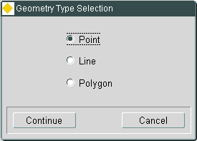

Once a Geometry Type has been selected and the [Continue] button selected, Locator will be called in Multi Point mode with the map zoomed to the current Work Order Line shape.

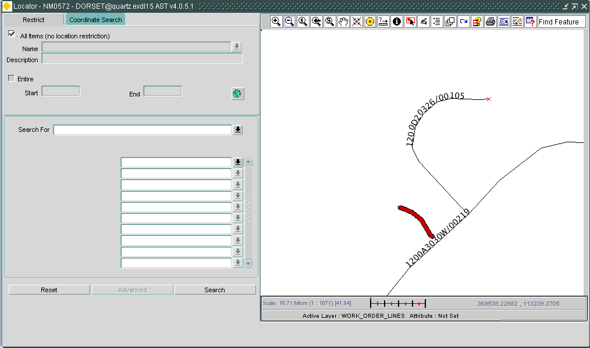

To define the new shape for the Work Order Line select “Send Multiple Points to application” from the “Feature Edit Menu” button in the Map as shown below
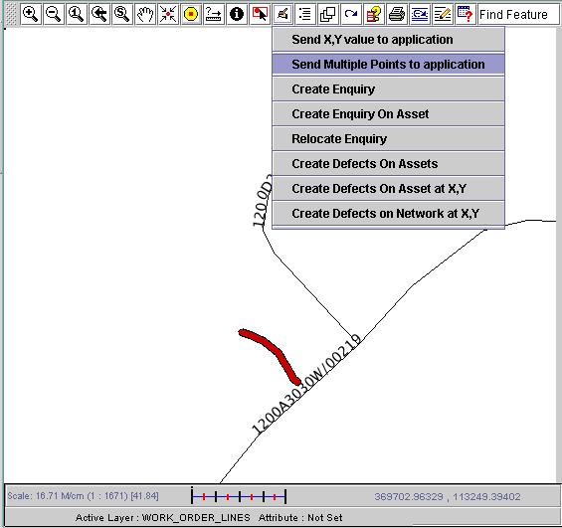

To return a point shape, just double click the Map at the desired point.
To return a Line or a Polygon click the required points on the map, remembering to double click the last point.

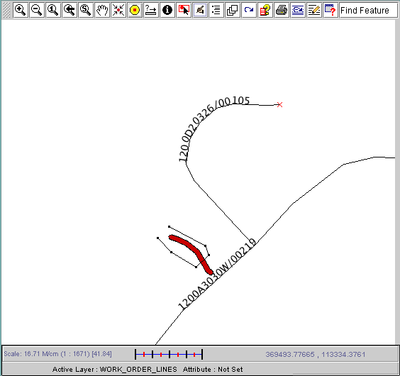

Once a double click is detected by the map the point(s) will be returned to mai3800.
If the user has returned points that do not match the selected Geometry Type and error will be raised and the Work Order Line shape will not be updated, for example:-

If the user selected Point and returns more than one point from the map the following error will be raised.
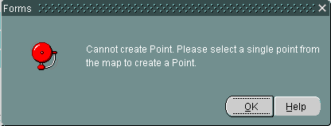

If the user selects Line and only returns one point from the map the following error will be raised.
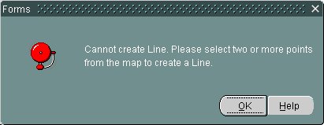
If the User selects Polygon and returns less than 3 points from the map the following error will be raised.
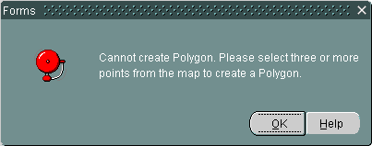

Finally if the user selects Polygon and the points returned lead to a self intersecting Polygon, for example:-
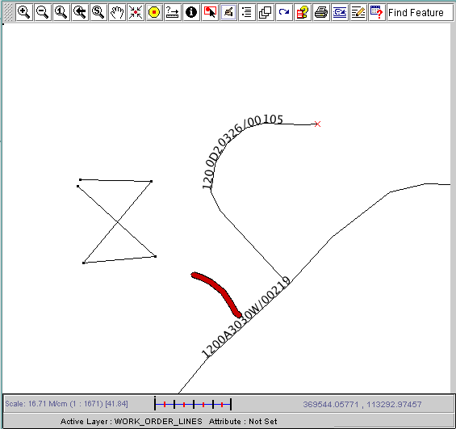
Then the following error will be raised.
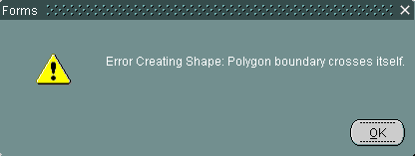

If no errors are raised by the form then the new shape has been generated and updated in the shape table. However it has not yet been committed. To save the changes the user must select [Save]

Once the change has been committed the new shape can be viewed in the usual fashion i.e. by pressing the Map button.

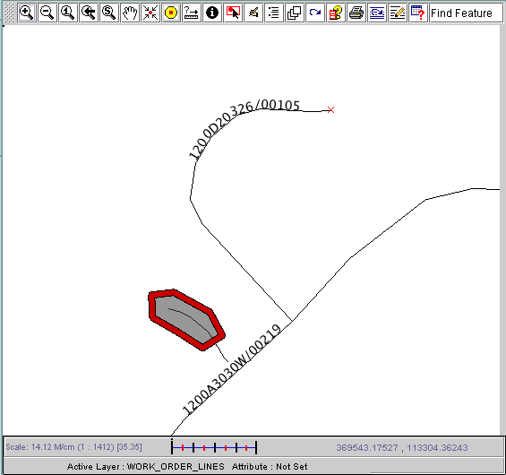

Note.
When the system has been unable to generate a default shape for the Work Order Line (for example the WOL is for a Group Of Groups) the [Get From Map] button will still work but will not zoom when initially called. It is up to the User to locate the area in which the work is to be carried out and then use “Send Multiple Points to application” from the “Feature Edit Menu” button to create a shape for the Work Order Line.
Once the change has been committed the new shape can be viewed in the usual fashion i.e. by pressing the Map button.

Spatial Representation of Work Order Lines.
General Information
In order to store a spatial representation of a Work Order Line a new standard set of Work Order Lines themes have been coded. GIS0020 should be used to create these Standard Themes.

To create the themes:-
- Select “Work Order Lines Layer” in the SDO Layer tree on the left hand side of the form.
- Enter a name for the Layer, for example WORK_ORDER_LINES.
- Enter a code and name for the Foreign Table Asset Type that will be created to allow the user to search for Work Order Lines in Locator, for example “WOLS” and “Work Order Lines FT Asset Type”.
- Press the “Create layer” button to create the Layer.

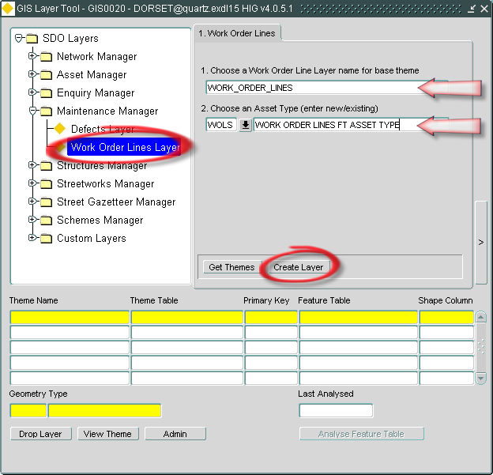
The creation of the Layer will take a few minutes as it sets up the Themes and generates shapes for existing Work Order Lines.

Note.
The automatic generation of shapes for existing Work Order Lines excludes the following Status Codes (based on the Status Code feature flags).

- COMPLETED
- HELD
- NOT DONE
- PAID
- ACTIONED

Once the Layer has been created, two themes should be displayed in the lower portion of the form:-
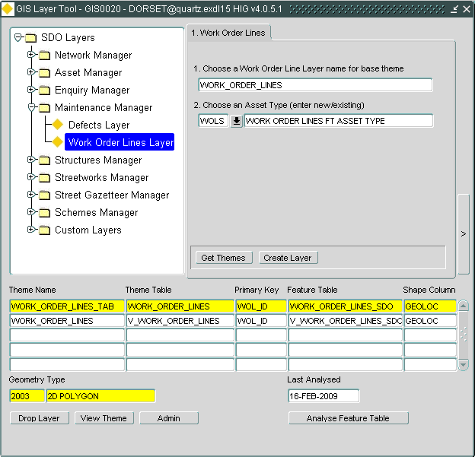

Once the Work Order Lines layer has been created any new Work Order Lines should have a default shape generated for them when they are committed. The following logic determines what shape will be generated:-

- If it’s a Defect Work Order Line generate shape from the Defect details
- If the Defect has x,y co-ordinates then use them to create a point
- Otherwise if the Defect has a Section and chainage then use them to create a point
- Otherwise use the whole shape for the Section that the Defect is on.
- Otherwise use the Element on the Work Order Line to generate the shape
- If the Element is a Group Of Sections then get the group shape
- If the Element is a Section get the section shape

Note.
Where the Work Order Line is NOT for a Defect the creation of a default shape will occur for a Datum Element or a Group Of Datum Elements. Therefore no default shape will be created for Lines where the Element is a Group Of Groups, this includes Groups Of Sections on a conflated network as the Section is itself a group of ESU’s.

.

- Log No. Summary
This chapter summarises all Software Bugs and Changes that have been made in this release. These changes are derived from Customer raised issues

Support Reference | Module | Issue
716756 | MAI3852 | Validation problem on Works Orders where completion date is after instructed date
718882 | MAI3854 | Resolves intermittent processing of WC files
714910 | MAI3807 | Sub-ordinate user validation against admin units
715703 | MAI3802 | Addresses Complete W.O. button being grayed out
717011 | MAI2250 | Boiler text obscured
713521 | MAI2315 | Section Range field not talking to Print Inventory items
704206 | MAI2325 | Errors when using Print Inventory Report
700858 | MAI2470 | Incorrect activity associated with a defect on a PEM
710853 | MAI2790 | Spurious error message when running MAI2790 report
710102 | MAI3485 | Error when running report
700268 | MAI3800 | Spurious error messages after changing BoQs
712737 | MAI3800 | WOR_Priority domain issues resolved
714140 | MAI3800 | Moving quickly between repairs on Defect form
718161 | MAI3800 | Validation on copying an authorized Works Order
715072 | MAI3800 | Copying Work Order amended no longer transfers authorisation
715126 | MAI3800 | Work Categories LoV description truncated
715859 | MAI3802 | Contractor unable to see rates and costs
708231 | MAI3806 | Defect Detail button not working
712453 | MAI3806 | Sub users are unable to query on dates
715212 | MAI3806 | Problems with wildcard searches in Defects form
716082 | MAI3806 | Admin unit validation on defects in Works Orders
717432 | MAI3808 | Issues with querying back road sections with an initiation type that is end-dated
711592 | MAI3862 | End dated sections showing in schedule
713267 | MAI3863 | Restriction on full list of active organisations recorded in MAI1870
703400 | MAI3899 | Issues retaining defect on Inspections by Group form
717935 | MAI3904 | Report layout – Bold Defect ID and Road Name
716903 | MAI3942 | Adds column width to Works Order sheet reference
711788 | MAI7040 | Ordering in PBI reports
707479 | MAI3899 | Inspection form ID sequence issues
716088 | MAI3907 | Print Cyclic Work Order sequencing

